EEN TALKs DAY !

1st JULY 2024
TALENT GARDEN
Turin (IT)

Amid the B2B Torino Sport & Fashion Match 2024, the international partnering event that facilitates the creation of international agreements and new partnerships between companies, suppliers and retailers from all over the world through pre-organised meetings, managed by Unioncamere Piemonte as partner of the Enterprise Europe Network, we are delighted to welcome you to this full working day of experiential TALK’s with international speakers !

Highlight

Are you interested in discovering new technological and industrial trends in the textile/fashion and sports sector, receiving insights on the new EU directives for the sustainability of the sector or boost your knowledge about many other industrial trends ?
Then, follow this DAY to be highlighted on :

AI and Metaverse, new digital and innovative industrial trends amid the textile industry

The New European Sustainable Regulation for Textiles

Future thinking and Foresight

Investments, Leaderships management and Female entrepreneurship

Internationalization and innovation services and activities with our EEN partners for all over the world supporting small and medium-sized enterprises with international ambitions

WHY TO JOIN THE DAY :

Join all the sessions and the inspirational PANELs with international speakers

Take the opportunity to follow for free the 2 Trainings offered to participants on Sustainability and IPR for the textile and Fashion industry !

Meet international experts, academics, investors and peers to leverage your network and your business !

Meet the Talent Garden team: the Turin’s leading cowork space for digital and tech innovators and get inspirations from their huge experience on innovation, startups and entrepreneurships knowledge!

Take time to relax in the cozy garden during our Closure Aperitif organized at Talent Garden premises and offered by the organizers to thank you for your kind participation !

THE AGENDA
h. 8.45 – 9.00 : Registration and WELCOME COFFEE

9.00 – 9.15
Welcome to the EEN TALK’ DAY !!
Presentation of the Programme and welcome speech
o Unioncamere Piemonte ..................(Regional Union of the Chambers of commerce of Piedmont Region) Partner of the Enterprise Europe Network
o Talent Garden

h. 9.15 – 9.45
The Enterprise Europe Network supports your brand to internationalize and to innovate sustainably
The Enterprise Europe Network and services for SMEs| Startups| young entrepreneurs with international ambitions !
o Federica Leonetti , Chair of the Textiles Sector Group and Enterprise Europe Network business Advisor at Unioncamere Piemonte
o Sven C. Oehme, LL.M. (Fordham Graduate School of Law), President & CEO European-American Business Organization, Inc, New York, Enterprise Europe Network USA (New York) : Market opportunities in the US for SMEs
o Marcio Antonio Magalhães Canedo, International Relations Section - SERIN , Instituto Brasileiro de Informação em Ciência e Tecnologia - IBICT ……… Enterprise Europe Network Brasil : Market opportunities for SMEs
o Sebastián Bustamante González Co-founder Impact Hub Medellín / Cali Bogotá Enterprise Europe Network Colombia Coordinator ……….. Enterprise Europe Network Colombia: Market opportunities for SMEs
o Leena Pishe Thomas, Director Global Business Inroads India , Enterprise Europe Network INDIA : Market opportunities for SMEs

h. 9.45 – 10.30 SUSTAINABILITY TRAINING SESSION
The new European Sustainable Regulation of Textiles (30m):
o ...........................................................EURATEX , EU strategy for sustainable and circular textiles
o .......................................................... European Recycling Platform: The EU Extended Producer Responsibility Directive amid the textile industry
o EEN supporting activities
h. 10.30 -11.30 PANEL DISCUSSION
The role of the Social and Circular economy amid the Textile industry :
Moderator : Sara Zampollo..........
Experts vs Startups:
- Fashion Revolution IT (The activist movement united in their diversity by the desire to make the fashion industry more ethical and transparent)TBC
- Global Fashion Agenda (The non-profit organisation that fosters industry collaboration on sustainability in fashion to accelerate impact) TBC
- Styleit, Fashion tech Aaccelerator (Vincenzo Rollo ) TBC
- Torino Social Impact (The fast-growing ecosystem for social entrepreneurship and impact investors)
- MUST HAD
- STEVE’S
- Second Hand
- Atelier Riforma
- Human Maple
- Colori Vivi TBC
h. 11.30 – 13.00 pm _IPR TRAINING SESSION
THE IP SME HELPDESK EXPERTs
o Federica De Curtis (China IP SME HELPDESK )
o Africa IP SME HELPDESK
o India IP SME HELPDESK
o East- Asia IP SME HELPDESK

h. 13.00. 13.45 Lunch break
h. 1.45 pm – 2.30 pm
FOCUS ON THE TEXTILE’ SPORT INDUSTRY
1. The EEN Sport Itinerary Project 2024
2. Sport Innovation Hub, Marta Serrano Executive Director at Sport Innovation Hub
3. EPSI European Platform for Sport Innovation
4 Heritage and Creativity : Project proposal , Fashion Team TBC
6. Politecnico of Turin (Ada Ferri) TBC
7. Atipici TBC

h. 2.30 – 3.00 pm_ PANEL DISCUSSION
LEADERSHIPS & INVESTMENT - FEMALE ENTREPRENEURSHIP & INCLUSION :
How to boost Entrepreneurship and innovation. Focus on supporting actions for female entrepreneurs (30 min)
Moderator: Giulia Pascuzzi : Trainer | Coach Strategy - Shining Bees

- EEN INNOVATE UK EDGE, Giulia Sirigu
- Torino Young Entrepreneurs, Barbara Graffino, President at Torino Young Entrepreneurs
Giulietta Testa, , CEO at Djungle Studio,
- Luca Torra, ……………. at LOCAL INCUBATORS : I3P AND 2i3T: supporting innovative startups TBC
- Savannah Hillebrand ……………..at USA Consulate Public Diplomacy Section TBC
- Sven C. Oehme, LL.M. (Fordham Graduate School of Law), President & CEO European-American Business Organization, Inc, New York, Enterprise Europe Network USA (New York)
- Buongiorno San Paolo TBC (companies ? )
- Marcio Antonio Magalhães Canedo, International Relations Section - SERIN , Instituto Brasileiro de Informação em Ciência e Tecnologia - IBICT ……… Enterprise Europe Network Brasil
- Sebastián Bustamante González Co-founder Impact Hub Medellín / Cali Bogotá Enterprise Europe Network Colombia Coordinator ……….. Enterprise Europe Network Colombia TBC

h. 3.00 – 4.00 pm _PANEL DISCUSSION
A.I. AND METAVERSE: INNOVATIVE INDUSTRIAL TRENDs ROCKING THE TEXTILES INDUSTRY
Moderator : …………….
1. Jonathan Napolitano : CEO Real Again | Web3 - Blockchain
2. Vincenzo Rana : CEO Knobs | Web3 - Blockchain
3. Fabio Foglia : CoFounder AiLandings – AI
7. Capable design .
8. Intraverse

h. 4.00 – 5.15 pm
FORESIGHT AND VENTURE CAPITAL to build FUTURE VISIONs
- Feat Ventures with Fabio Sferruzzi : venture Builder
- Diyala D’aveni: Head of Vento
- Jacopo Romei : Head of Garage Startupbootcamp

H. 5.30 pm – 6.30 pm
Closure Aperitif & Farewell
at
TALENT GARDEN
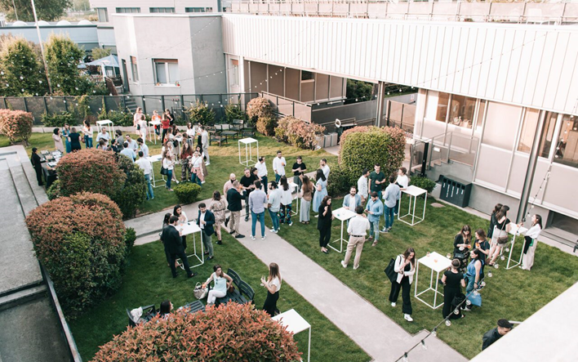
THANKS FOR JOINING !!

The event is realized and managed by Unioncamere Piemonte with the support of the Turin Chamber of Commerce as partners of the Enterprise Europe Network, the largest European network that helps SMEs to grow, innovate and internationalize and with the contributions of Talent Garden’s experts, the Turin’s leading coworking space for digital and tech innovators!!

NOTES :
- To join the activity just REGISTER on the b2b platform : https://torino-fashion-match-2024.b2match.io/page-4101
- A free Coffee station will be available all day long during B2B Sessions + TALK’S DAY
- Lunches are not included (you can join the Coffee bar inside the Talent Garden
- On the 1st July a Closure Aperitif will be offered by Unioncamere Piemonte in collaboration with Enterprise Europe Network!

